**Assignment #1: Websites conceptual Design and mock-up**

**Mohanned Ahmed Ali , 222101696**

**2.3.1 part 1: research**

**1.Characteristics of Web Definitions 2.0 to Web 4.0**

.Web 2.0 also called the social web, is the second stage of the web evolution. It includes social media, collaborating content like Wikipedia and blogs, and other interactive apps. What sets it apart is participation and collaboration, where users can participate and contribute.

Often called the semantic web, web 3.0 offers more advanced data analysis and implies that volumes of content or pages can be understandable by machines. It makes use of artificial Intelligence, data mining, and machine learning to link and and analysis of information. Hence, users can have a more personalized experience.

Web 4.0 is still largely a concept but encompasses a intelligent web that connects everything including devices, AI and the internet. The aim of this network is to operate predictive technologies and serve customers better.

**2.The Power of Networks is empowered by key features of Web 2.0.**

Web 2.0 features have social networking, blogging, tagging and content sharing like YouTube, Facebook. It allows people to connect with one another all over the world, share content instantly and participate in online communities.

Web 3.0 is equipped with several features which help in linking data and knowledge.

**3. Key Features of Web 3.0 and How It Empowers Data and Knowledge Connections**

Web 3.0 has rich features like semantic searching, data mining, and also AI customization. Web 3.0 utilizes these technologies to link together different sources of data so that users can receive more meaningful, contextualized, and relevant information. This will allow better discovery of knowledge from data connections as the systems will understand the information better.

See Journal of Semantic Web, MIT Technology Review for more on Web 3.0. 16 words

**4. Key Features of Web 4.0 and How It Empowers Intelligence Connections**

Web 4.0 aims at Website design with more intelligent-device compatible. Its focus will be on creating a scenario where systems are equipped to know what you want before you ask. Web 4.0 can facilitate the flow of service across connected devices with the help of IoT and advanced AI, allowing intelligence on connections in a seamless automated way**.**

**1**

**5. Importance of Collective Intelligence, Social Networking, Social Media, and Social Bookmarking**

The ability of a group of people to solve problems can be more effective than that of an individual. Social networking and social media both of them connect people and build a community. Social bookmarking lets users organize and manage links which can be shared. Knowledge sharing, innovation, and collaborative decision-making is supported by this.

If you’re looking for an academic point of view, check out research from Harvard Business Review about collective intelligence. You may also want to visit ScienceDirect for some articles about social media and its use in society.

### **6. How These Technologies Empower Current and Future Business Plans**

These technologies drive innovation, enhance customer engagement, and streamline operations. Businesses can leverage data analytics from social media to understand customer preferences, use Web 3.0’s semantic features for personalized marketing, and apply Web 4.0’s predictive capabilities for proactive services. These trends enable data-driven, agile business strategies that can quickly adapt to market changes.

### **7. How You Intend to Use the Latest Technologies in Your Profession**

To answer this question, reflect on your field and how these technologies might be applied to optimize workflows, improve customer satisfaction, or drive innovation. For instance, if you're in marketing, Web 3.0 could help tailor campaigns to individual customers, while Web 4.0 could provide real-time, data-driven insights to enhance decision-making.

**2.3.2 part 2: website planning:**

**2**

**1. Website Purpose**

Purpose: Electro Verse will serve as a non-intimidating, user-friendly online home for the amateur electronics enthusiast. This website will provide an abundance of products that will be showcased, everything from laptops and smartphones to all varieties of peripherals, with extensive descriptions and reviews to aid in making the best choices. The

website will also inform its visitors of emerging trends in technology, requests for feedback, and any type of assistance desired, directly through their monitor.

**2. Website Aims**

A few key goals that the website will look to achieve is as follows:

Ease of Sale and Better Brand Recognition: To make it easy for customers to find and buy what they need.

Customer Service: Through a dedicated help section with an FAQ and live chat, we will be there to answer questions and provide help when needed.

Community Building: Through the blog and newsletter, we keep customers updated with the latest electronics and send special promotions right to their inbox.

Get Feedback: Harkening to our customers will be very helpful in updating the site and continuous improvement of our services.

**3. Target Audience**

Target Audience: We reach out to technology enthusiasts, casual shoppers of electronics, and small business enterprises who want devices and accessories. In general, anybody looking for reliable, clearly explained information and a hassle-free shopping experience in their technological needs.

**4. Website's Coverage Opportunity and Challenges**

Opportunities: By going online, we will be able to reach larger numbers and make the shopping process easier for them. We will be able to learn from the consumer interactions and help ourselves grow and improve.

Challenges: We are aware that people may have a number of questions when it comes to electronic devices with regards to specifications, compatibility, and value for money. Hence, the website will make an honest attempt to provide clear and elaborative answers to these queries in order to enable customers to make decisions with confidence.

3

**5. Content to Include**

Here is what we will provide to make the site as informative as possible: full product information, including pictures, so the shoppers would know what they get; a blog with articles on technology-related matters that would update the visitors on trends, releases, and how to do things; easy decision-making comparison charts; customer testimonials of the experiences of real customers; video demos of popular items to see them in action; and user reviews/ratings to give the community a feel while building trust.

**6. How the Website Will Help the Consumers**

Benefits: We wish for consumers to be able to use their time in a much less stressful way when buying, by being able to do the following:

asily locate products and buy them directly on the website.

Get full details along with the comparison of available models to choose the best for their needs.

Avail special offers and discounts

If they happen to have any questions or problems, get immediate assistance through live chat or FAQs

**7. What's the Best Thing Users Can Do to Do What Is Required**

How It Works: We 'll make the site user-friendly with the following features:

Intuitive navigation that will organize products into categories like "Laptops" and "Smartphones."

Clearly worded calls-to-action, like "Buy Now" or "Add to Cart."

Forms will be provided for signing up to receive newsletters, creating an account, or contacting support.

**8. Directing Users toward What They Need**

Finding Features: We 'll keep things organized by:

A top menu of product categories so the customers know where to start.

A search bar so they can directly jump to what they' re looking for. Clearly visible buttons on each page for most important actions, such as seeing their cart or accessing their account. **9. How Users Receive Results After Actions Results:**

After any action that took place, like placing an order or signing up for updates, users get a response: Order confirmations are shown in their inbox.

4

Any questions they submit via live chat or email will be responded to as soon as possible.

Newsletter sign-ups will be thanked with a confirmation email to let them know they're on the list.

**10. What We'll Do with the Information Users Submit**

Processing Entries: Here's how we'll handle the information we collect:

Orders are routed to our fulfillment team who process and ship.

Customer queries are followed up with by the support team, who are ever willing to support.

Marketing will also keep updating the newsletter list and ensuring news and any offers are sent to clients.

**11. How We'll Manage Results**

Managing Results:

Customer service follows up with any problems or queries.

Marketing continues follow-up with newsletters and follow-up emails.

**12. Follow-up Needed**

Aftercare:

Tracking information will be sent to clients upon dispatch of orders.

We'll send out periodic newsletters to keep our subscribers informed.

Feedback after a sale may be solicited as a means of helping us improve.

**13. Comparable Sites and Rationale**

BestBuy.com: This was selected as an example because it has a clean format, easy navigation, and a host of customer reviews with which a customer could become confident and trust.

Newegg.com: It is well-renowned for its details on products, customer-generated reviews, and technical data. It's just excellent to learn from the way relevant information delivery and customer interaction goes on.

**14.prepare the planning analysis sheet that include the following:**

**5**

### **a. Website Goal**

* **Define the primary purpose of the website.** For example, if your website is for an online store, the goal might be to facilitate e-commerce by showcasing products and enabling online purchases. Alternatively, if it's an informational blog, the goal could be to share insights on specific topics, attract readers, and build a community.

### **b. List of Page Titles**

* **Brainstorm seven to eleven pages for the website, excluding the homepage.** Think about the various sections a typical website would need to fulfill its purpose. Here are some common examples:
  + About Us
  + Products/Services
  + Blog
  + Contact Us
  + Testimonials
  + FAQs
  + Gallery
  + News
  + Resources
  + Careers
  + Privacy Policy

### **c. Description of Contents for Each Page**

* **Describe the expected contents on each page** (facts, text, images, videos, etc.). Here’s a sample structure:
  + **Homepage:** Brief introduction, main services/products highlights, and call-to-action buttons.
  + **About Us:** Company history, mission statement, team photos.
  + **Products/Services:** List of offerings, descriptions, pricing, and customer reviews.
  + **Blog:** Articles, comments section, categories for posts.
  + **Contact Us:** Contact form, location map, phone numbers.
  + **Testimonials:** Customer testimonials and ratings.
  + **FAQs:** Frequently asked questions with answers.
  + **Gallery:** Photo gallery showcasing products or events.

6

* + **Resources:** Downloadable content (e.g., whitepapers, guides).
  + **Careers:** Job openings, company culture.
  + **Privacy Policy:** Legal information about data usage and privacy.

### **d. Description of Form Usage**

* Explain how forms will be used on the website. Consider different forms depending on your site’s function:
  + Contact Form: Allow visitors to reach out with questions.
  + Registration Form: For signing up for accounts or events.
  + Newsletter Subscription Form: Collect emails for sending updates.
  + Feedback/Comment Forms: Allow users to provide feedback or comments on posts.
  + Survey or Poll: Get user opinions or conduct research.
  + Order/Quote Request Form: For users to inquire about services or products.

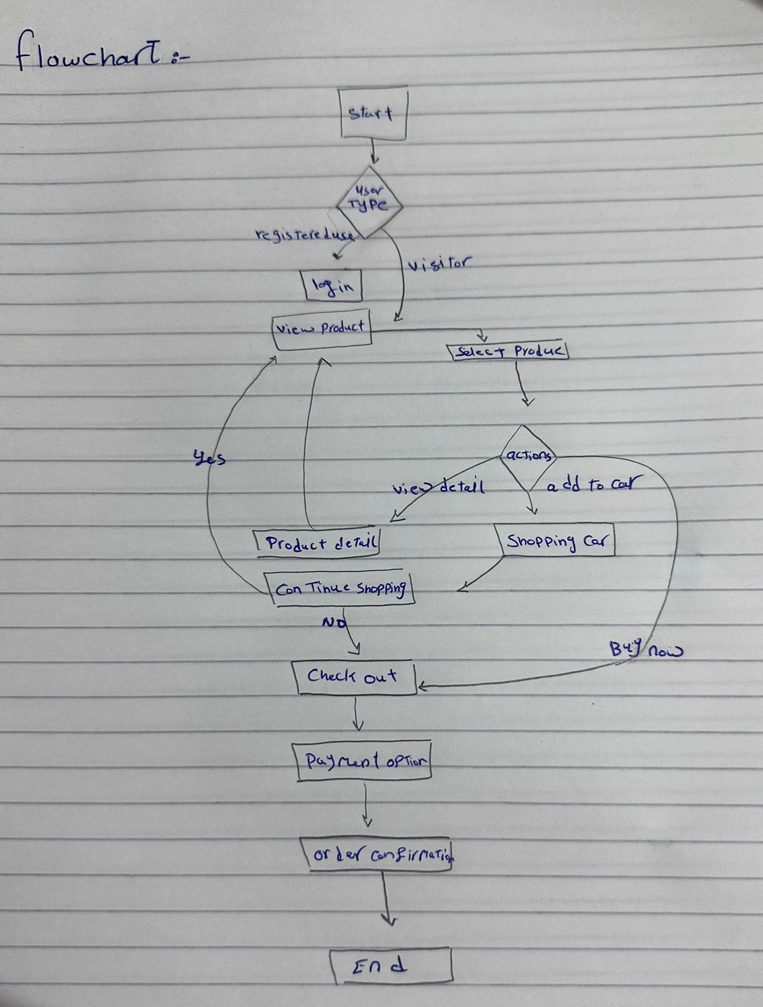

7

**F.wireframe:**

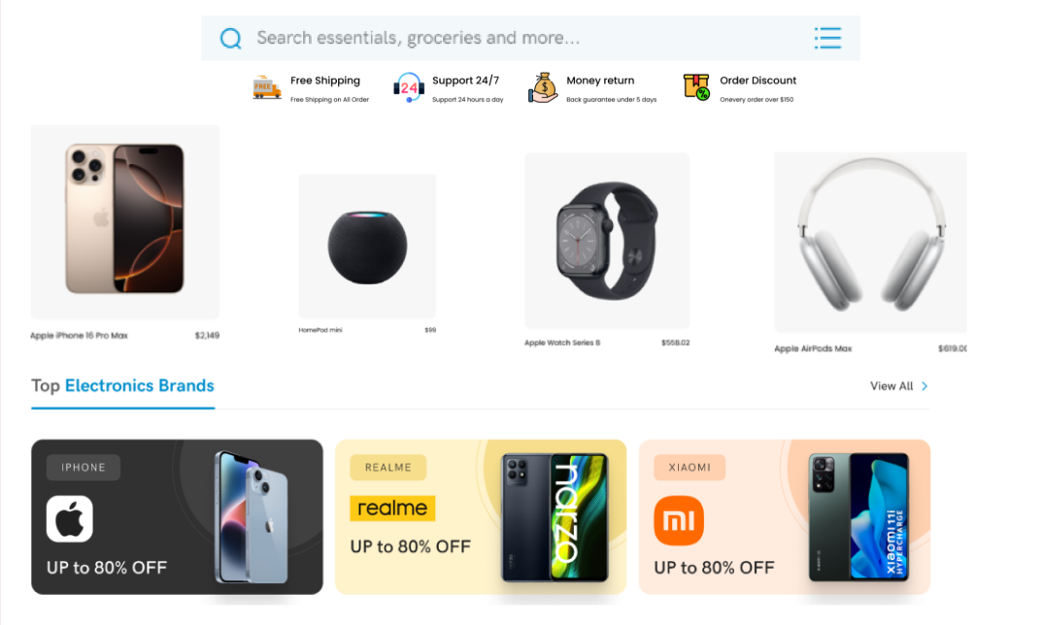

**[B] Deployment of other design concepts**

1- Screen Resolution: 685 x 579 pixels.

**2- Pick a color palette using Adobe Color Wheel CC or Paletton. take a screen shot, and include it in your submission:**

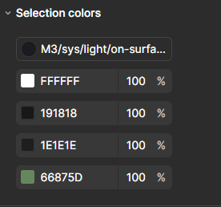 8

**3- Set the minimum contrast accepted for accessibility:**

#### **1. Spotting Key Areas**

* First, take a close look at areas with **text, icons, and interactive elements**—especially in the footer, navigation bar, and main sections. These are where contrast is most critical for readability and usability.

#### **2. Understand the Minimum Contrast Levels**

* For **regular text** (like descriptions or smaller links), aim for a minimum contrast ratio of **4.5:1**.
* For **larger text** (anything over 18pt, or 14pt bold), the minimum ratio drops to **3:1** since larger text is generally easier to read.
* For **non-text elements** (like icons and buttons), the contrast should be at least **3:1** to make sure they stand out enough to be recognized and used.

#### **3. Using Tools to Check Contrast**

* Tools like [WebAIM’s Contrast Checker](https://webaim.org/resources/contrastchecker/) or the [Color Contrast Analyzer](https://developer.paciellogroup.com/resources/contrastanalyser/) are handy for this step.
* Take the color values (hex codes) for the text and background colors from each section of your site and plug them into one of these tools. It will show you if the current contrast meets accessibility standards.

#### **4. Where to Focus Adjustments**

* **Footer Text**: Check the white text against the green background in the footer. If the contrast is lower than 4.5:1, you may want to darken the green background or slightly lighten the text color to increase readability.
* **Buttons and Links**: For all buttons and links (like the “View All” button or social media icons), ensure they meet at least a 3:1 contrast ratio. This will make interactive parts of the site more noticeable and easy to use.

9

### **Making These Changes**

Adjusting contrast is often a simple CSS tweak. Here’s how you could go about it:

* **Text Colors**: Try slightly lighter or darker shades of your current colors to see if they meet the standards without a huge visual shift.
* **Background Colors**: If text contrast is still low, darkening or lightening the background can make text much easier to read without changing your design style.

**4- Front-end development technologies:**HTML5 ,CSS,JS.

**5- Content Management Systems (CMS).**

**Popular CMS options:**

* **WordPress:**
  + Highly customizable and user-friendly.
  + Vast library of themes and plugins.
  + Ideal for blogs and smaller e-commerce stores.
* **WooCommerce:**
  + Built on WordPress.
  + Powerful e-commerce platform.
  + Offers features like product management, shopping cart, and payment gateways.
* **Shopify:**
  + Cloud-based e-commerce solution.
  + Easy setup and management.
  + Suitable for online stores of all sizes.
* **Magento:**
  + Highly scalable and feature-rich.
  + Best for large e-commerce businesses with complex product catalogs.

10

**Less common but possible options:**

* **Drupal:**
  + Complex but highly customizable.
  + Suitable for large-scale websites with advanced functionalities.
* **Joomla:**
  + User-friendly and versatile.
  + Can be used for both small and large websites.

**To determine the exact CMS used, you can:**

1. **Inspect the source code:** Look for specific elements like plugin names, code patterns, or comments that might indicate the CMS.
2. **Check the website's source code:** Look for specific elements like plugin names, code patterns, or comments that might indicate the CMS.
3. **Search for clues in the website's structure:** Look for common patterns used by specific CMSs, such as specific folder structures or file naming conventions.
4. **Contact the website owner:** They might be able to provide information about the CMS they are using.

6-Back-end development technologies:PHP

**7-Metrics your planning to use website performance**

### **1. Loading Speed**

* **How fast does the main content appear?** Ideally, visitors should be able to see the main part of any page in under 2.5 seconds.
* **How responsive is the site?** When users click something, it should respond in less than 100 milliseconds to feel immediate.
* **Are there any unexpected shifts?** We’ll check that nothing jumps around as the page loads, which can be frustrating.

### **2. User Engagement**

* **Do visitors stay or leave quickly?** If people click away after just one page, that might mean they didn’t find what they were looking for.
* **Are they exploring the site?** Tracking how many pages each visitor views helps us see if they’re genuinely interested.

11

* **Are they spending time with us?** The longer visitors stay, the more likely they are finding content they enjoy.
* **Are they taking action?** We want to know if visitors are buying products, signing up for newsletters, or clicking on promotions. These are signs of a healthy, engaging site.

### **3. Accessibility**

* **Is everything easy to read?** Text needs to stand out from the background for readability—especially for users with visual impairments. We'll make sure color contrasts meet recommended standards.
* **Is it keyboard-friendly?** People with limited mobility often rely on keyboards instead of a mouse, so we’ll ensure they can navigate the site easily.
* **Do images have descriptions?** Alt text helps screen readers interpret images, which is essential for visually impaired visitors.

### **4. Search Engine Visibility**

* **Are people finding us on Google?** Organic traffic (free search engine traffic) shows how visible we are to new visitors searching for products like ours.
* **Do people click through from search results?** We’ll track how often searchers choose to visit ElectroMart over competitors when they see us in Google results.
* **Is the site mobile-friendly?** With so many people shopping on their phones, the site has to look and work great on smaller screens too.

### **5. Customer Satisfaction**

* **Are visitors happy with the site?** We can ask users directly through surveys, especially after they buy something or contact support.
* **How quickly do we respond to questions?** If we offer customer support, fast responses matter. We’ll keep an eye on response times for customer questions.

### **6. Security and Reliability**

* **Is the site secure?** HTTPS is a must to protect users’ data, and we’ll ensure all pages are secure.
* **Are there any broken links or missing images?** We’ll regularly check that all links and resources work to avoid dead ends.
* **Is the site protected from malware?** Routine scans for vulnerabilities will help keep the site safe for everyone.

13

**8-HTML STRUCTURE:**

1. index.html (Home Page)

<!DOCTYPE html>

<html lang="en">

<head>

<meta charset="UTF-8">

<meta name="viewport" content="width=device-width, initial-scale=1.0">

<title>Electromart - Home</title>

<link rel="stylesheet" href="styles.css">

</head>

<body>

<header>

<div class="logo">ELECTROMART</div>

<nav>

<a href="index.html">Home</a>

<a href="about.html">About</a>

<a href="shop.html">Shop</a>

<a href="product.html">Product</a>

<a href="contact.html">Contact Us</a>

</nav>

</header>

<section class="search-bar">

<input type="text" placeholder="Search essentials, groceries and more...">

</section>

<section class="services">

<div>Free Shipping</div>

<div>Support 24/7</div>

<div>Money Return</div>

<div>Order Discount</div>

</section>

<section class="featured-products">

<!-- Featured Products would go here, similar to the main HTML template in the previous answer -->

</section>

14

<section class="brand-promotions">

<!-- Brand promotions like iPhone, Realme, and Xiaomi go here -->

</section>

<footer>

<!-- Footer links and social media icons go here -->

</footer>

</body>

</html>

2. about.html (About Page)

<!DOCTYPE html>

<html lang="en">

<head>

<meta charset="UTF-8">

<meta name="viewport" content="width=device-width, initial-scale=1.0">

<title>Electromart - About Us</title>

<link rel="stylesheet" href="styles.css">

</head>

<body>

<header>

<div class="logo">ELECTROMART</div>

<nav>

<a href="index.html">Home</a>

<a href="about.html">About</a>

<a href="shop.html">Shop</a>

<a href="product.html">Product</a>

<a href="contact.html">Contact Us</a>

</nav>

</header>

<section class="about-content">

<h1>About Us</h1>

<p>Welcome to Electromart, your one-stop shop for the latest in electronics...</p>

<!-- Add more company information here -->

</section>

15

<footer>

<!-- Footer links and social media icons go here -->

</footer>

</body>

</html>

### **3. shop.html (Shop Page)**

<!DOCTYPE html>

<html lang="en">

<head>

<meta charset="UTF-8">

<meta name="viewport" content="width=device-width, initial-scale=1.0">

<title>Electromart - Shop</title>

<link rel="stylesheet" href="styles.css">

</head>

<body>

<header>

<div class="logo">ELECTROMART</div>

<nav>

<a href="index.html">Home</a>

<a href="about.html">About</a>

<a href="shop.html">Shop</a>

<a href="product.html">Product</a>

<a href="contact.html">Contact Us</a>

</nav>

</header>

16

<section class="shop-categories">

<h1>Shop by Categories</h1>

<!-- Categories like Laptops, Smartphones, Tablets, etc. -->

</section>

<section class="shop-products">

<!-- Products list that users can browse through -->

</section>

<footer>

<!-- Footer links and social media icons go here -->

</footer>

</body>

</html>

4. product.html (Product Page)

<!DOCTYPE html>

<html lang="en">

<head>

<meta charset="UTF-8">

<meta name="viewport" content="width=device-width, initial-scale=1.0">

<title>Electromart - Product Details</title>

<link rel="stylesheet" href="styles.css">

</head>

<body>

<header>

17

<div class="logo">ELECTROMART</div>

<nav>

<a href="index.html">Home</a>

<a href="about.html">About</a>

<a href="shop.html">Shop</a>

<a href="product.html">Product</a>

<a href="contact.html">Contact Us</a>

</nav>

</header>

<section class="product-details">

<h1>Product Name</h1>

<img src="product-image.jpg" alt="Product Image">

<p>Price: $XXX.XX</p>

<p>Description: This product is...</p>

<!-- Add product details, specifications, reviews, etc. -->

</section>

<footer>

<!-- Footer links and social media icons go here -->

</footer>

</body>

</html>

5. contact.html (Contact Us Page)

<!DOCTYPE html>

<html lang="en">

<head>

18

<meta charset="UTF-8">

<meta name="viewport" content="width=device-width, initial-scale=1.0">

<title>Electromart - Contact Us</title>

<link rel="stylesheet" href="styles.css">

</head>

<body>

<header>

<div class="logo">ELECTROMART</div>

<nav>

<a href="index.html">Home</a>

<a href="about.html">About</a>

<a href="shop.html">Shop</a>

<a href="product.html">Product</a>

<a href="contact.html">Contact Us</a>

</nav>

</header>

<section class="contact-info">

<h1>Contact Us</h1>

<p>Email: support@electromart.com</p>

<p>Phone: +1 (800) 123-4567</p>

<form action="submit-contact" method="post">

<label for="name">Name:</label><br>

<input type="text" id="name" name="name"><br>

<label for="email">Email:</label><br>

<input type="email" id="email" name="email"><br>

19

<label for="message">Message:</label><br>

<textarea id="message" name="message"></textarea><br>

<button type="submit">Submit</button>

</form>

</section>

<footer>

<!-- Footer links and social media icons go here -->

</footer>

</body>

</html>

**Referencing:**

[**https://www.technologyreview.com/**](https://www.technologyreview.com/)

[**https://www.researchgate.net/**](https://www.researchgate.net/)

[**https://hbr.org/**](https://hbr.org/)

[**https://www.sciencedirect.com/**](https://www.sciencedirect.com/)

[**https://sloanreview.mit.edu/**](https://sloanreview.mit.edu/)

[**https://www.gartner.com/**](https://www.gartner.com/)

[**https://www.nngroup.com/**](https://www.nngroup.com/)

[**https://www.smashingmagazine.com/**](https://www.smashingmagazine.com/)

[**https://blog.hubspot.com/**](https://blog.hubspot.com/)

[**https://contentmarketinginstitute.com/**](https://contentmarketinginstitute.com/)

[**https://www.surveymonkey.com/**](https://www.surveymonkey.com/)

[**https://www.bestbuy.com/**](https://www.bestbuy.com/)

[**https://www.webfx.com/**](https://www.webfx.com/)

[**https://developer.mozilla.org/**](https://developer.mozilla.org/)

[**https://iapp.org/**](https://iapp.org/)

[**https://gdpr.eu/**](https://gdpr.eu/)

[**https://analytics.google.com/**](https://analytics.google.com/)

**20**